SPT and Bicep Starlink Verification

DSL Spectrum Measurement

Version: 1.1

Alexander Pollak & Maclean Rouble
Alexander.Pollak.87@gmail.com
January 31, 2023

This document summarizes testing done Dec 14 2022 - Jan 24 2023. It examines the link’s impact on the RF spectrum as measured from the Dark Sector, and documents several mitigation strategies attempted and their effectiveness.

Measurement Setup

A spectrum analyzer with directional feed horn antenna was set up in the Dark Sector on the roof of the Dark Sector Lab to record the local RF spectrum. The spectrum analyzer measures from 14 to 14.5 GHz with a resolution bandwidth of 3MHz. It operates a max hold function for 15 minutes, then saves the spectrum to disk.

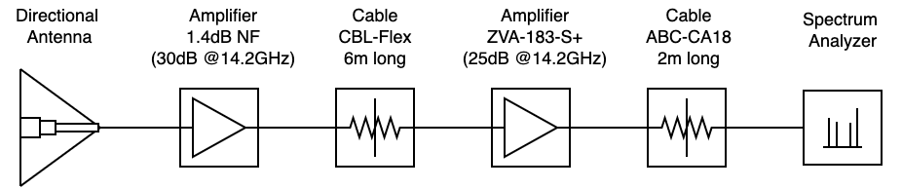
Above: Schematic diagram of the measurement setup. The first amplifier is mounted directly to the feed horn to minimize any attenuation before the first stage of amplification.

Description | Designation
Feed Horn | ETS Model: 3115
Amplifier 1 | (30dB @14.2GHz, 1.4dB NF)
Cable | Mini Circuit CBL Flex 6 m length
Amplifier 2 | Mini-Circuits ZVA-183-S+  (25dB @14.2GHz, 3.14dB NF)
Cable | AtlantecRF ABC-CA18-SMSM, 2 m length
Spectrum Analyzer | Anritsu MS2724B
Table: Components used for the measurement setup.

Description | Setting
Resolution | 401 points
Center Frequency | 14.248 GHz
Span | 0.5 GHz
RBW | 3 MHz
VBW | 1 KHz
Sweep Time | ≈ 866ms
Attenuator | 0 dB
Trace Operation | max hold
Table: Spectrum Analyzer settings.
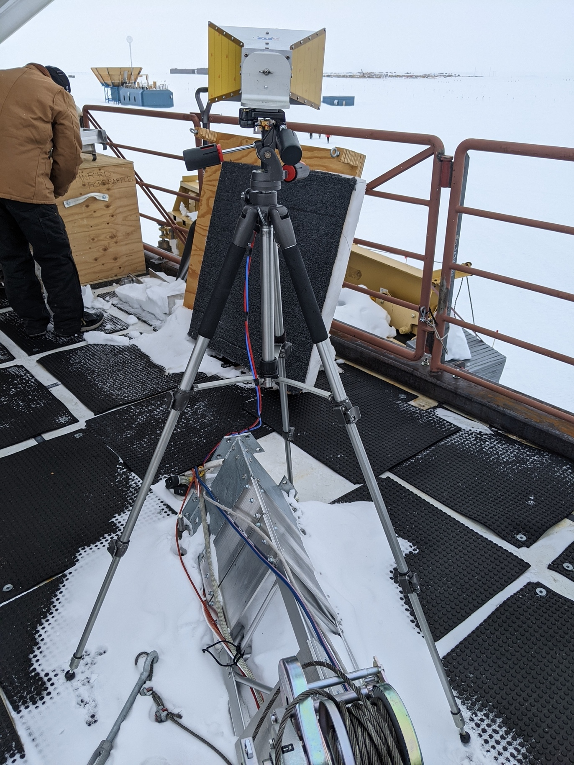
Above: picture of the feed horn measurement setup at DSL. Showing the feed horn pointing in the direction of SPRESSO.

2.0 Data Analysis

We began recording spectra on Dec 15, after the Starlink antenna was moved to the roof of the building in the RF sector, and continued recording spectra since then. This allowed us to compare the spectral contents for different orientations and mitigation configurations, like the installation of the absorber panels.

The raw spectra are saved in daily “.csv” files containing 96 individual 15 min max hold traces. Notice, that the Starlink transmission is not constant and varies throughout the day depending on which satellites the antenna connects to and which frequency band it uses. Therefore, the spectral power changes as a function of frequency and as a function of time, making it difficult to discern individual spectra effectively. However, comparing the average detected power between days is consistent enough to compare different Starlink antenna configurations.

An example plot of the measured spectrum without the Starlink antenna transmitting is shown below. The plot shows all recorded spectra from a single day, with yellower colours indicating a later time of day. The data was collected on Dec 21, 2022. Note, we have seen some quantization readout artifacts, most of them are within 0.5dB and always peak in groups at the same level.
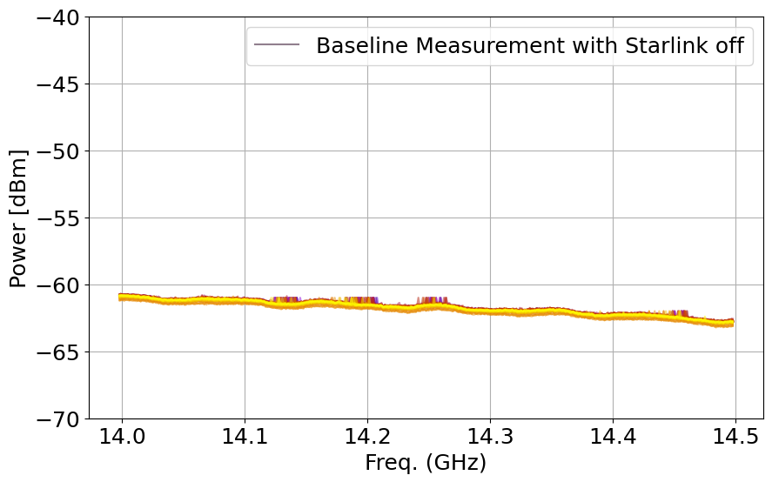
Above: all recorded spectra from a single day, with yellower colours indicating a later time of day. (Date: Dec 21, 2022)

3.0 Results
For this report we focus on one day of data for each configuration. Each section contains a picture of the setup, a 24-hour spectra, and a Starlink connectivity plot extracted from the IceCube Grafana monitor.
The spectra are plotted with identical axis and therefore can be compared directly. We also included two maps pointing out the location of the Starlink antenna in the RF Sector and at SPRESSO.

3.1 RF Sector antenna location
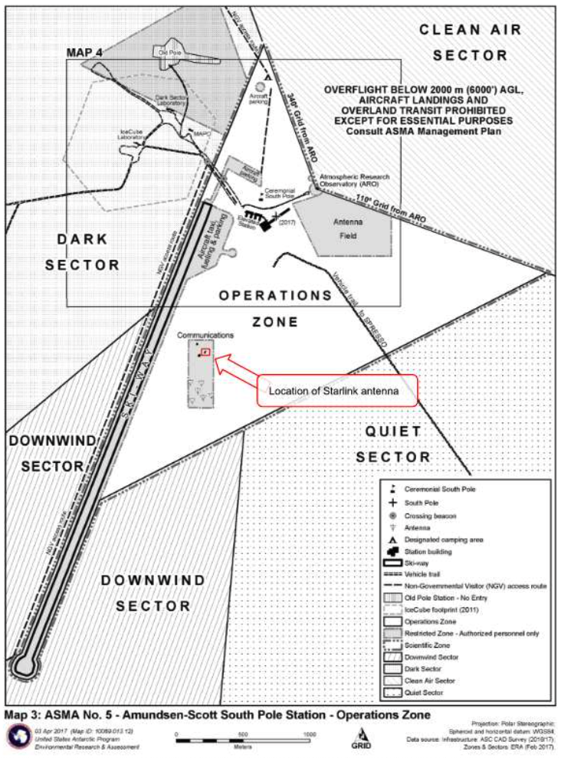
Above: image from the South Pole Station intranet, with the location of the Starlink antenna marked in red.

3.1.1 Configuration 1: RF Sector location without absorber

For the first configuration we placed the Starlink antenna on the roof of the RF building to minimize obstructions. The antenna was also mounted with the original tripod, which allowed it to move freely. After the initial setup the antenna settled at an elevation of about 60 deg and an azimuth direction of grid North-West towards the Dark Sector. After the antenna initially orientated itself, we could not observe any further movement for the couple of days we took data in that configuration.

The data used for this configuration was taken during the following period: Dec 14-16, 2022.

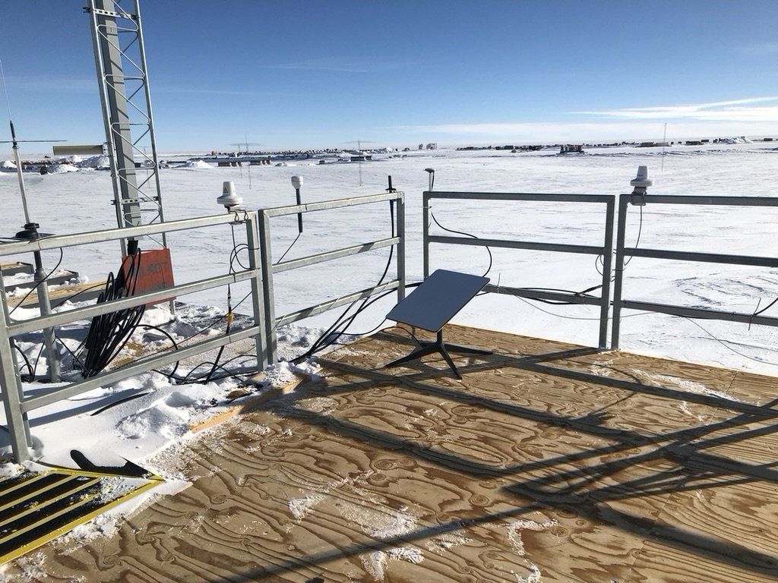
Above: shows the Starlink antenna installed on the roof of the RF sector building, pointing towards the Dark Sector.

The measured spectra for a day in this configuration is shown in the plot below. Comparing this plot with the base line plot from the previous section, we can see that for most of the Starlink frequency bands the power level is about 15 to 20 dB above the noise floor. Again, each color represents 15 min max hold spectra, where more yellow colours indicate a later time.
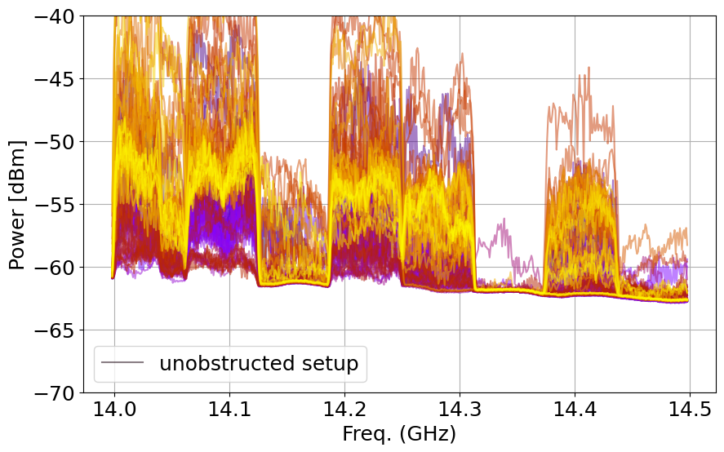
Above: all recorded spectra from a single day, with yellower colours indicating a later time of day. (Date: Dec 15, 2022)

The other metrics that we look at for our tests is the connectivity of the Starlink terminal. Basically, what is the percentage of the terminal reporting that it established a link with a satellite. This metric is recorded from the Starlink service data and is visualized with Grafana. For this configuration we have about 99 percent connectivity in a 24 hour window. There are only a few instances where we did not get a ping, or no downlink, marked in blue and purple, respectively.
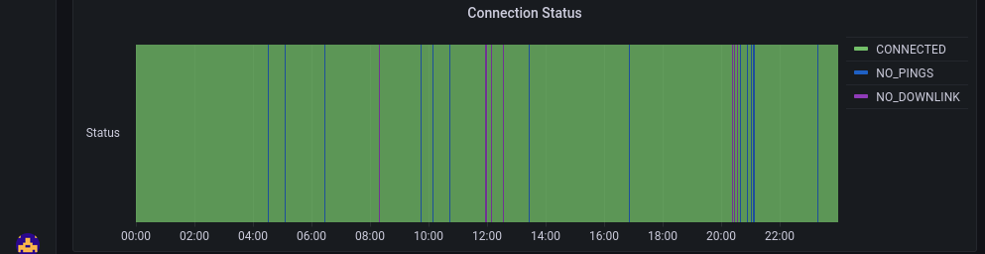Above: Shows the connectivity data for the Starlink terminal, green indicates connected. (about 99 percent connected)

3.1.2 Configuration 2: RF Sector location with absorber

For this configuration we placed absorber panels in the line of sight of the Dark Sector.
The panels consist of plywood - metal - echosorb foam. The metal acts as a reflector, and the foam is an RF attenuator. Signals sent in the direction of the panels are attenuated once as they enter the foam, then are reflected by the metal, and attenuated again as they exit.
There are three panels:
- 2x 4’x4’ with approx. -10dB foam (black)
- 1x 2’x4’ with approx. -20dB foam (white)

The Starlink antenna was kept in the same location and orientation. Thereby allowing us to compare the effect of the absorber panels without changing any other parameter in the test setup.

The data used for this configuration was taken during the following period: Dec 16-20, 2022.

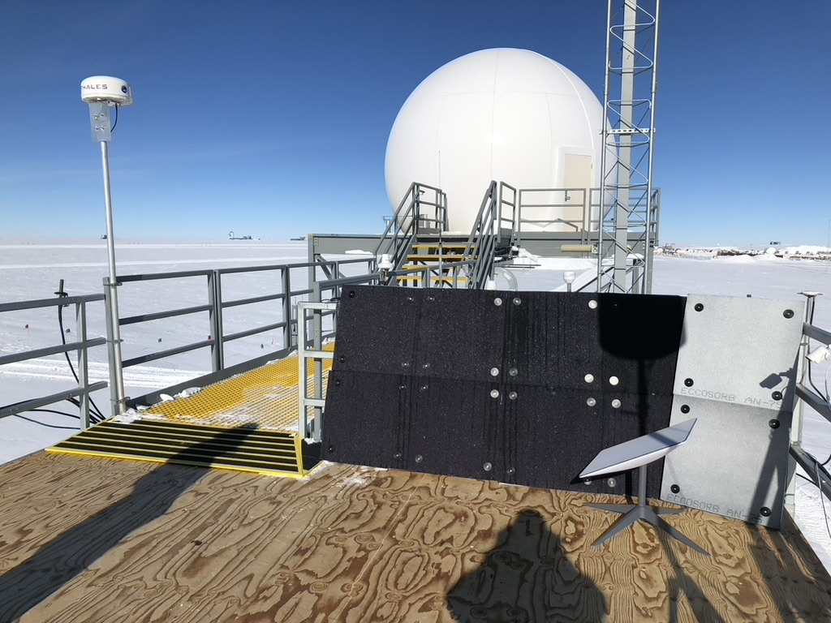
Above: panels temporarily installed in the RF sector, adjacent to the antenna. The dark sector is visible in the background to the left of the white dome.

The spectra for this configuration showed a decrease of about 10dB compared to the measurement without the absorber panels present. However, even with shielding the Starlink antenna with absorber panels we still can see the signal clearly.
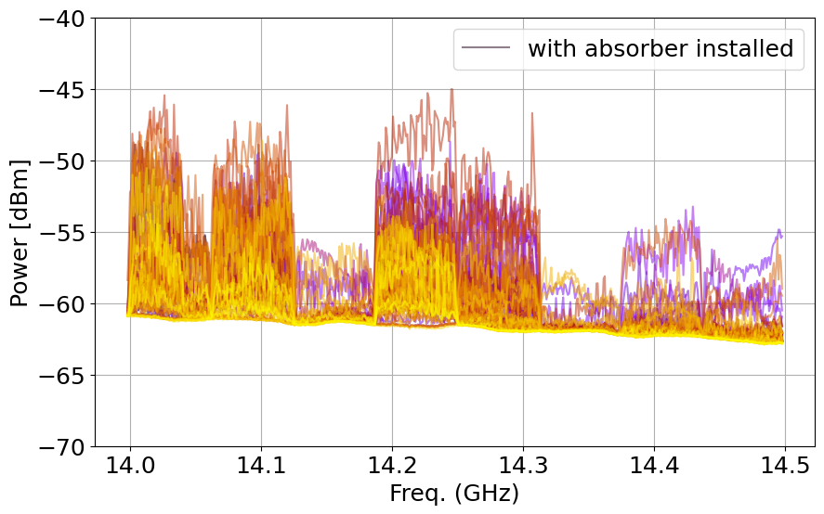Above: all recorded spectra from a single day, with yellower colours indicating a later time of day. (Date: Dec 17, 2022)

Looking at the connectivity data for this configuration we can see that the absorber panels significantly impact the ability to establish a link with the satellite. With this configuration the antenna achieves about 84 percent connectivity.

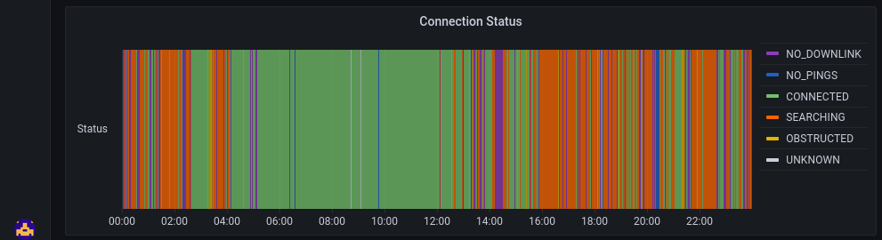
Above: Shows the connectivity data for the Starlink terminal, green indicates connected. (about 84 percent connected)

3.1.3 Configuration 3: RF Sector location with absorber and fixed mount

For this configuration we mounted the Starlink antenna in a frame that prevents it from moving freely, thereby allowing us to set the elevation and azimuth pointing. With the antenna motion deactivated, we pointed the antenna at the same elevation as it used to point when it was free moving, 60 deg elevation, and set the azimuth direction to be grid South-East, pointing it in the opposite direction of the Dark Sector.

The data used for this configuration was taken during the following period: Dec 26-28, 2022.

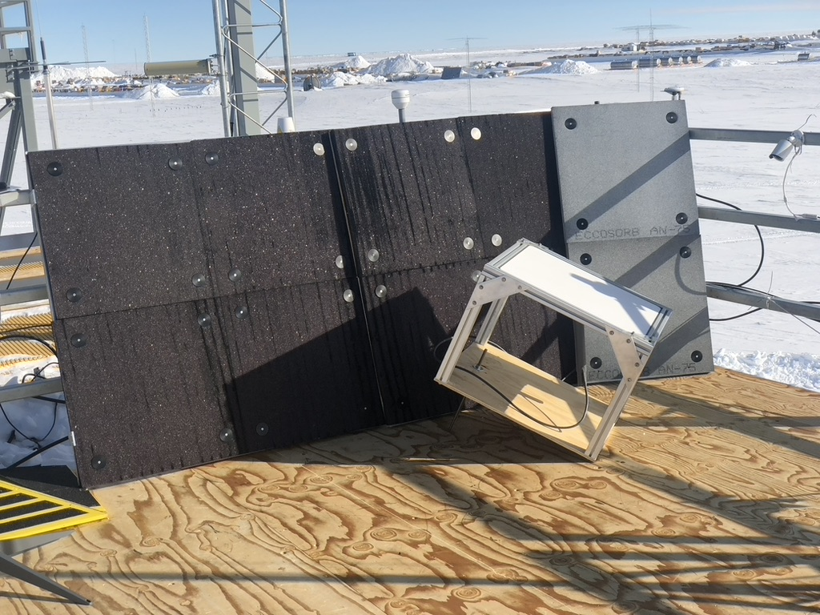
Above: Starlink antenna mounted in a frame that prevents it from moving freely. The picture shows it pointing approximately 60 deg in elevation and South-East in azimuth.

The spectra for this configuration looks similar to the one shown in configuration two where the antenna was pointing towards the Dark Sector. This measurement shows that even by physically changing the antenna orientation while keeping it at the same location does not lead to significant reduction in signal strength as seen from the Dark Sector. The beamforming capabilities of the Starlink antenna counteract any physical orientation change and lead to similar interference levels regardless of its primary orientation.
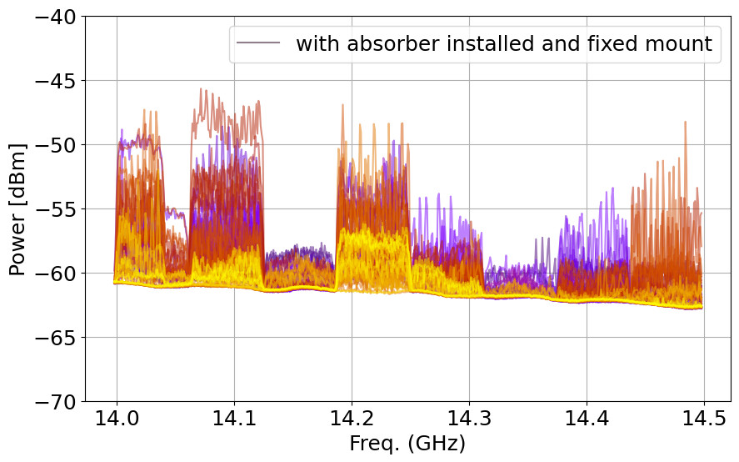
Above: all recorded spectra from a single day, with yellower colours indicating a later time of day. (Date: Dec 27, 2022)

The connectivity data for this configuration shows and even worse ability of the antenna to establish a link with the satellite. With this configuration the antenna achieves about 70 percent connectivity
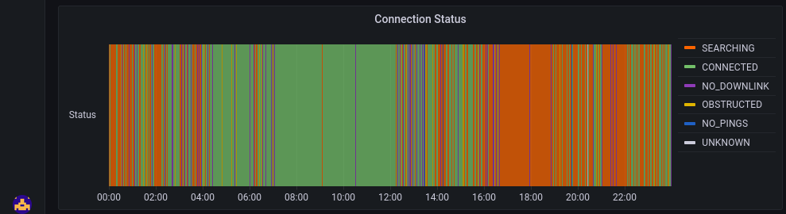
Above: Shows the connectivity measurement for the Starlink terminal, green indicates connected. (about 70 percent connected)

3.2 SPRESSO location

For the next set of configurations we moved the Starlink antenna to the SPRESSO location in the Quiet Sector. The antenna location is approximately 10 km away from DSL in the grid South-East direction. There are two tests planned for this location, first using the frame to set the pointing of the antenna to zenith and second allowing the antenna to free move with the original tripod.
The location of the Starlink antenna and the Dark Sector Lab is shown in the map below and indicated by the red arrows.

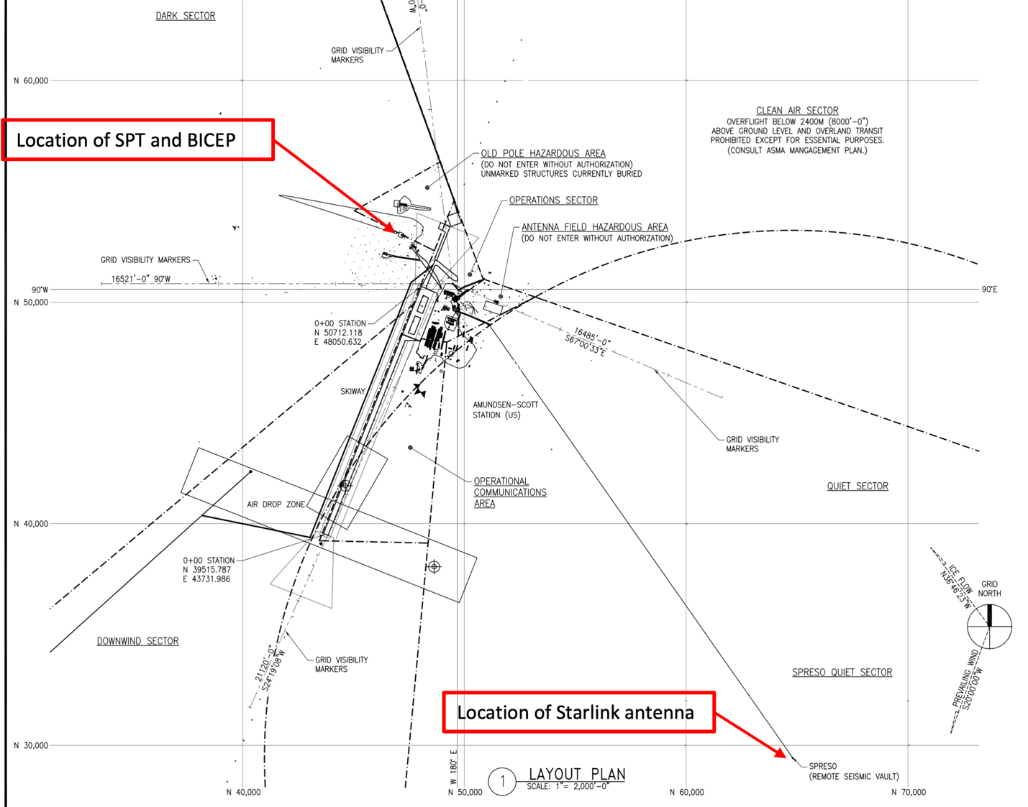

Above: image from the South Pole Station intranet, with the location of the Starlink antenna and the DSL. Distance between SL and DSL is approximately 10km.

3.2.1 Configuration 4: SPRESSO location pointing to zenith

For this configuration we placed the Starlink antenna in the mounting frame and located it on the ground at approximately 7m distance from the SPRESSO instrumentation vault. See picture below.

Antenna installed at SPRESSO in fixed frame, pointing to zenith (Jan 17-24)

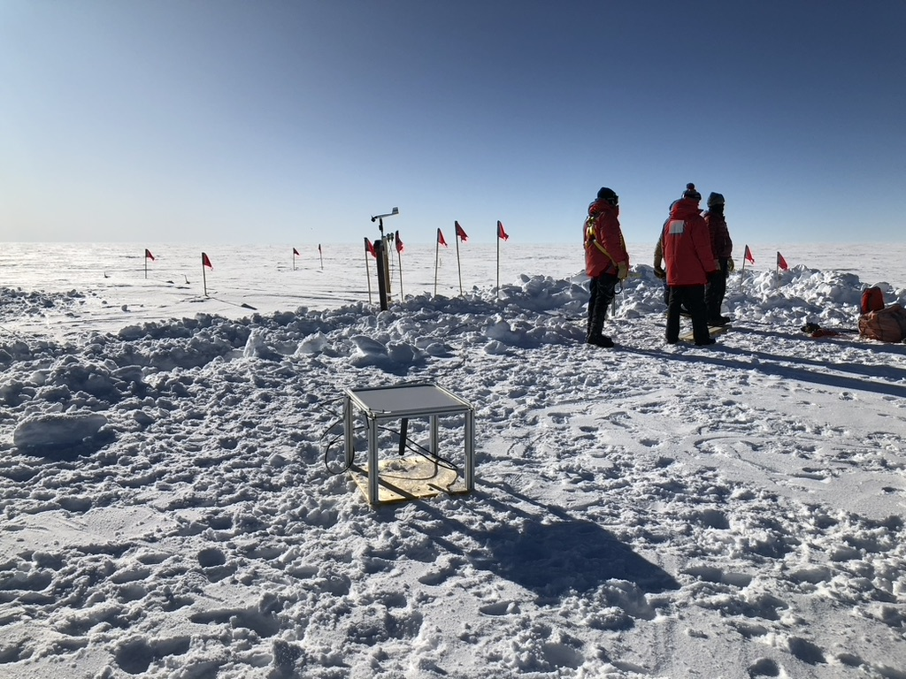
Above: Starlink antenna temporarily installed at SPRESSO. The flags in the center mark the hatch to the instrumentation vault.

To measure the spectra for this configuration we realigned the measurement setup to point in the direction of SPRESSO. This changed the baseline level to a slightly lower value compared to the original baseline presented in the Data Section. Significant here is that we can barely see the Starlink transmission in the spectra. There are only a few occasions where the signal is slightly above the noise floor. This is so far the most promising configuration and shows an effective approach to minimizing the impact of Starlink at the Dark Sector.
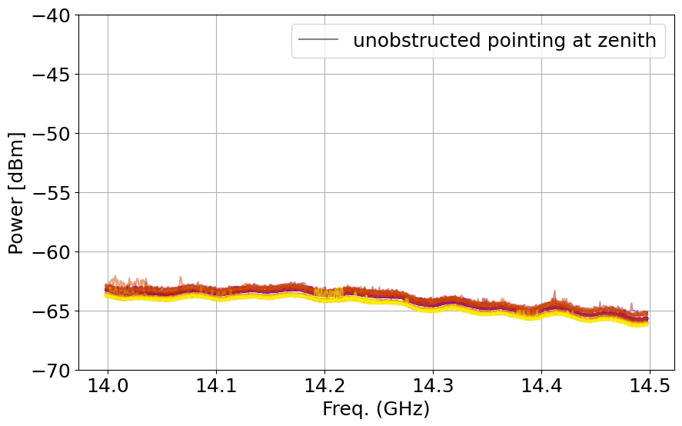
Above: all recorded spectra from a single day, with yellower colours indicating a later time of day. (Date: Jan 21, 2023)

Furthermore, the connectivity of this configuration shows a nearly 100 percent ability of the Starlink terminal to establish a link to the satellite. Note that this plot shows the connectivity for the last seven days of testing.
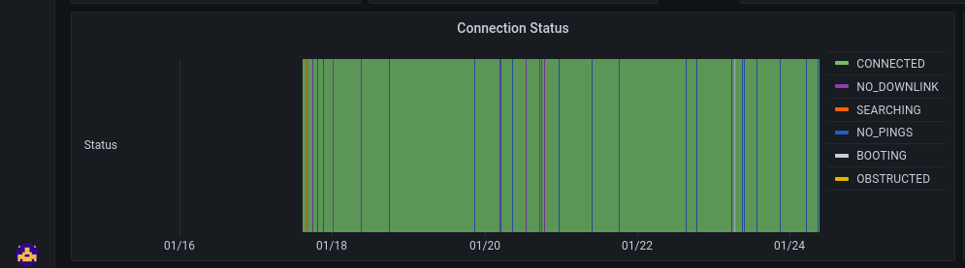
Above: Shows the connectivity measurement for the Starlink terminal, green indicates connected. (about 100 percent connected)

3.2.1 Configuration 4: SPRESSO location pointing freely

For this configuration we removed the fixed antenna mount and installed the Starlink antenna on its factory pole mount. The pole mount allows the antenna to freely move and point to its preferred direction. After powering up the antenna it orientated itself to grid North-West, same orientation as when it was installed at the RF sector.

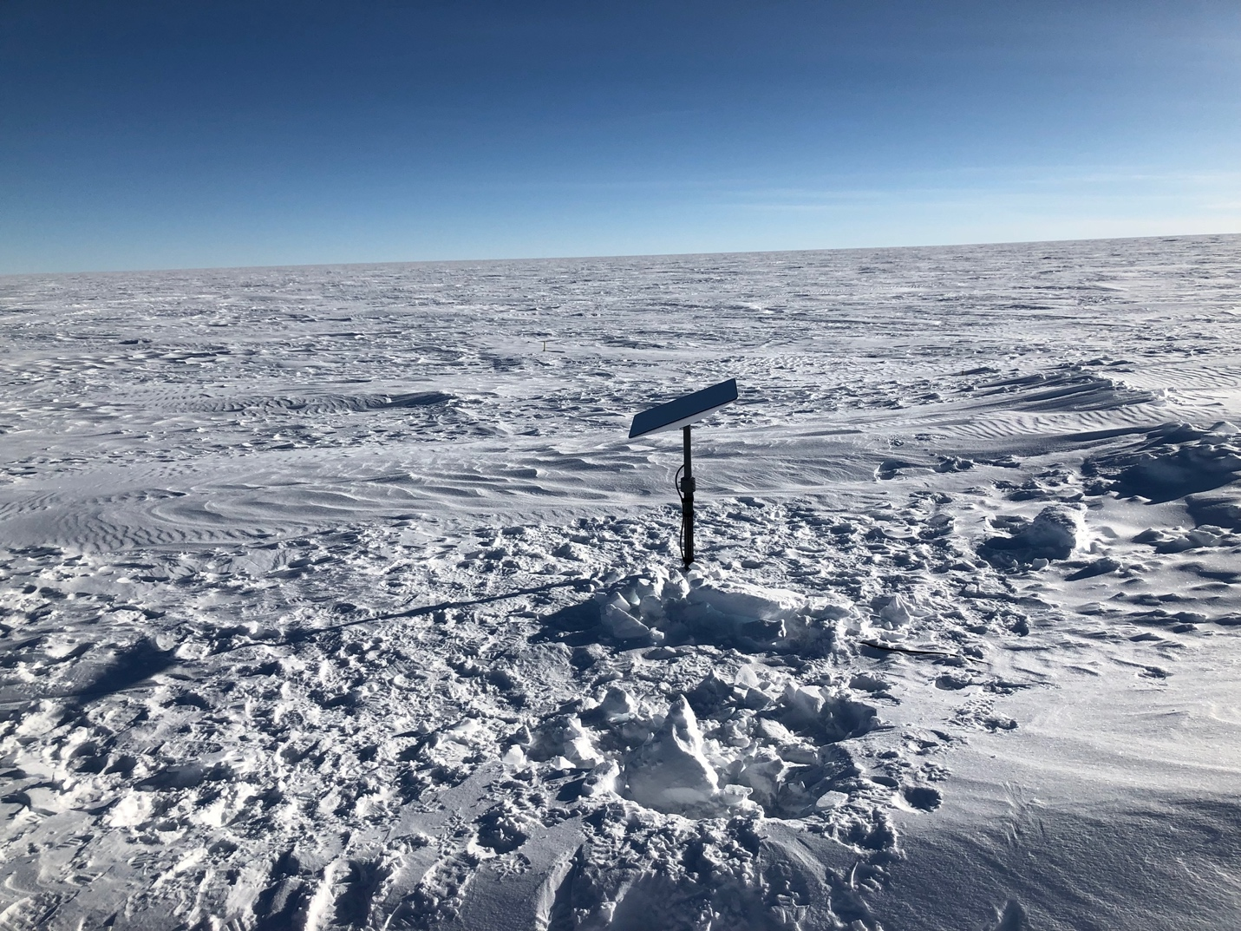
Above: Starlink antenna installed on the factory pole mount. With this configuration the antenna can freely move.

With the antenna pointing in the grid North-West direction we were able to pick up the the uplink above the noise floor again. From the first 24 hours of data, we can see that the signal strength is about 5 dB above the noise floor. This result is still significant better than any other configuration from the RF Sector. Our theory is that with the antenna being able to tilt to a lower elevation, it can beamform to satellites closer to the horizon and therefore transmissions going towards the direction of the Dark Sector can be low enough in elevation, so that the DSL might be in the primary beam.
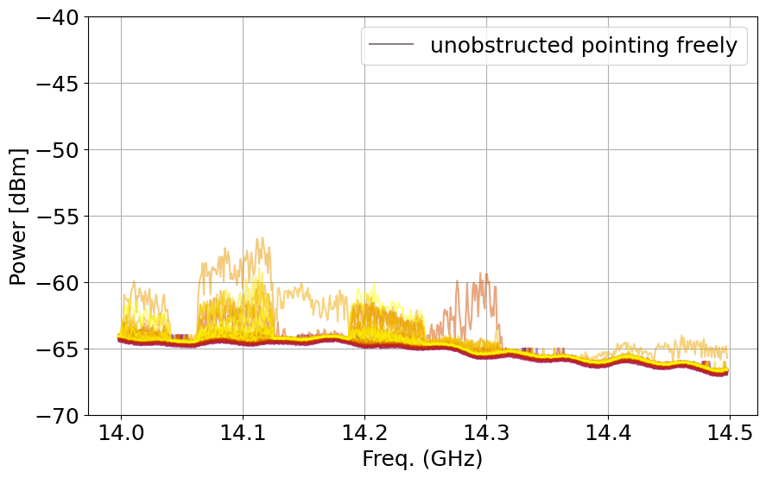
Above: all recorded spectra from a single day, with yellower colours indicating a later time of day. (Date: Jan 30, 2023)

The connectivity of this configuration nearly 100 percent. There are some short 1-2 min drops when Starlink moves the antenna to point to zenith for searching operation. Note that this plot shows the connectivity for the first 24 hours after installing it on the pole mount.
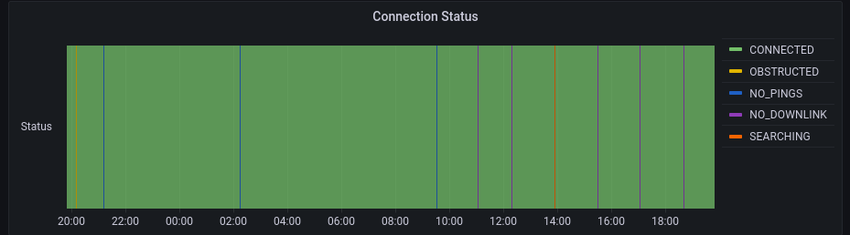
Above: Shows the connectivity measurement for the Starlink terminal, for the free moving configuration, green indicates connected. (about 100 percent connected)

4 Conclusion

Based on the results of the different configurations, we recommend locating the Starlink antenna at SPRESSO or a similar location. This will minimize any risk and impact to the science observations performed by SPT and BICEP.
However, this report does not conclude that placing Starlink at SPRESSO or a similar location eliminates any impact on science data. We can only conclude that such a location will minimize the risk of impacts to these science experiments. The final verification must come from analyzing the science data over the long term.

And finally, to compare the Starlink transmission to the TDRSS satellite link, we changed the center frequency of the spectrum analyzer measurement setup at DSL to 15GHz and recorded the spectrum.

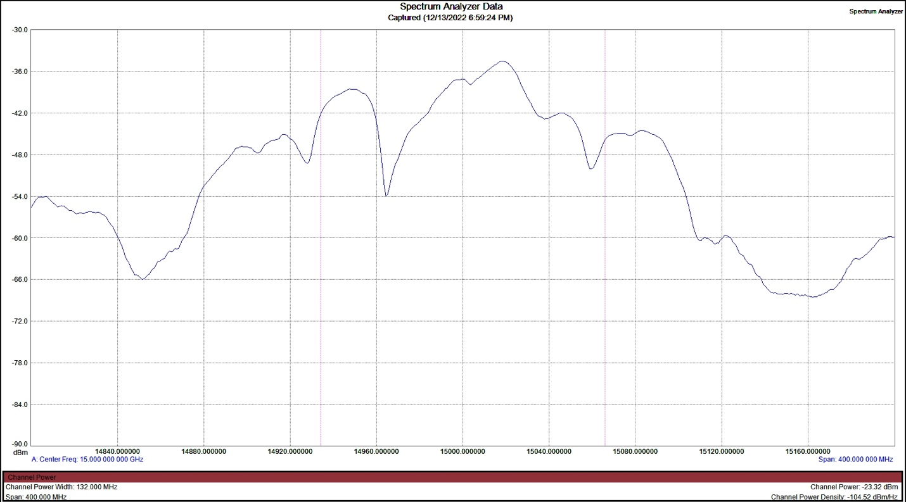
Above: spectrum of the TDRSS satellite link measured with our test setup from the dark sector, by pointing the feed horn in the direction of the RF Sector.

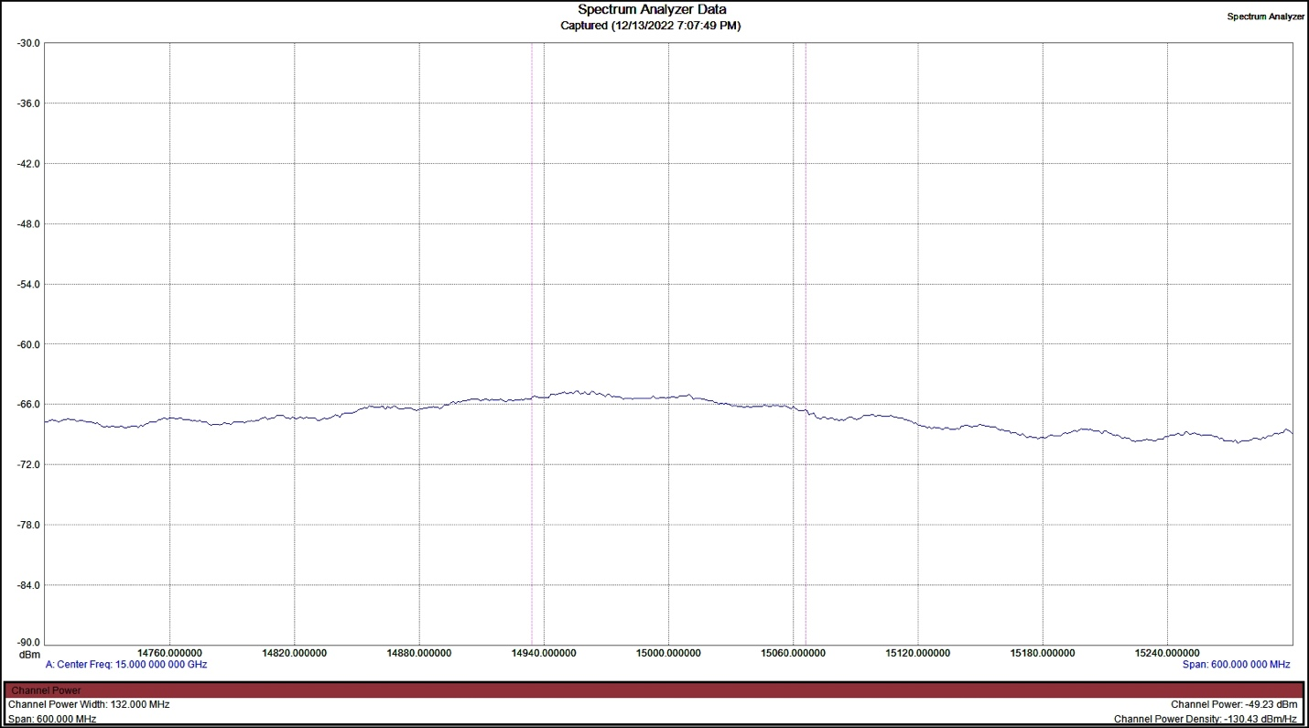
Above: baseline spectrum without the transmission, showing the baseline noise floor.

